DAILY ONLINE ACTIVITIES SUMMARY
Date: |  | 28/05/2020
Name of the Faculty |  | Ankitha Shetty
No. of Students Allotted for monitoring |  |  |  |  | 16
Progress |  |  |  |  | Good
Whether collected report from all the allotted students |  |  |  |  | 11 submitted
Online Test Summary
Subject | Aadalitha kannaad
Semester | 4 |  |  | Duration |  | 50
No. of students Taken |  |  | 83 | Passing % |  | 95
Certification Course Summary
Course |  | 1)The Future of Artificial Intelligence by ICT Academy  2) Networks & Security  3) Webinar on Building Machine Learning / DL Applications for Big Data
Certificate Provider |  |  |  |  | Duration
Coding Challenges
Problem Statement:
Status:
Uploaded the report in Github |  |  |  |  | Yes
If yes Repository name |  |  |  |  | https://github.com/ankishetty91/ankitha-daily-report
Uploaded the report in slack |  |  |  |  | Yes

Certification Course Summary
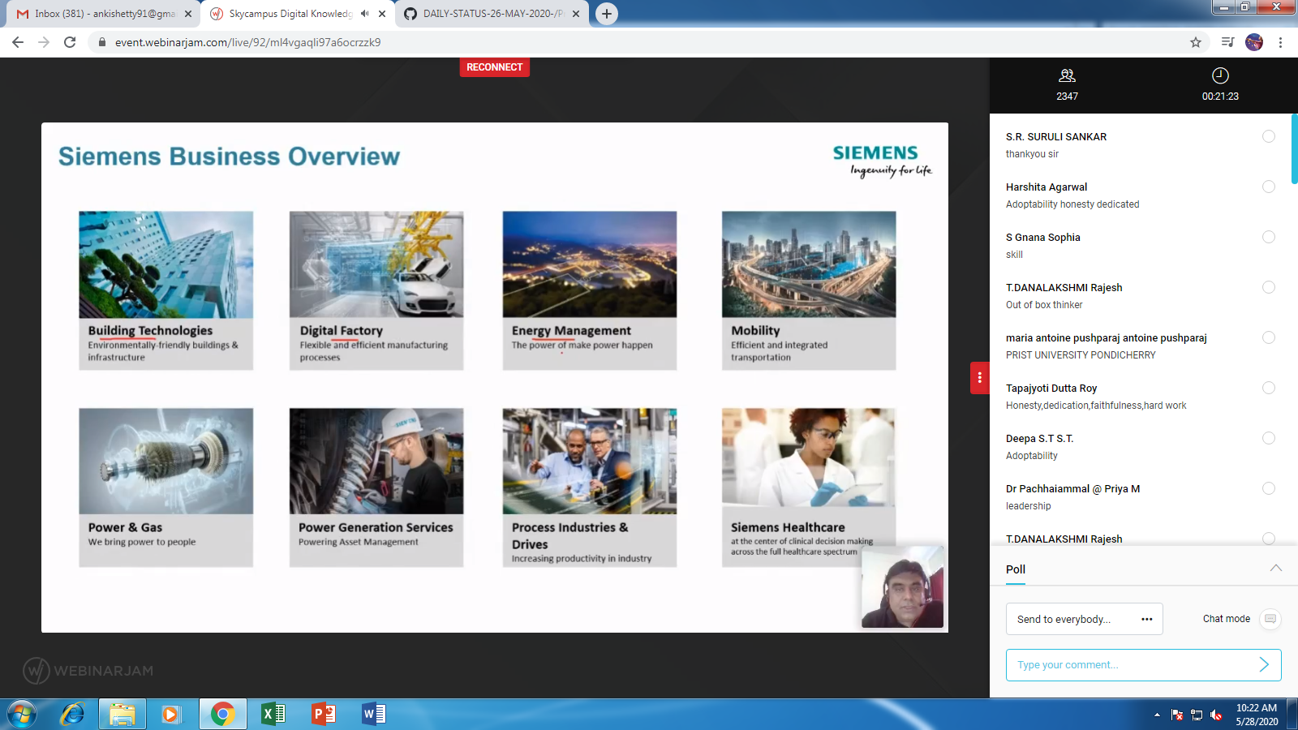
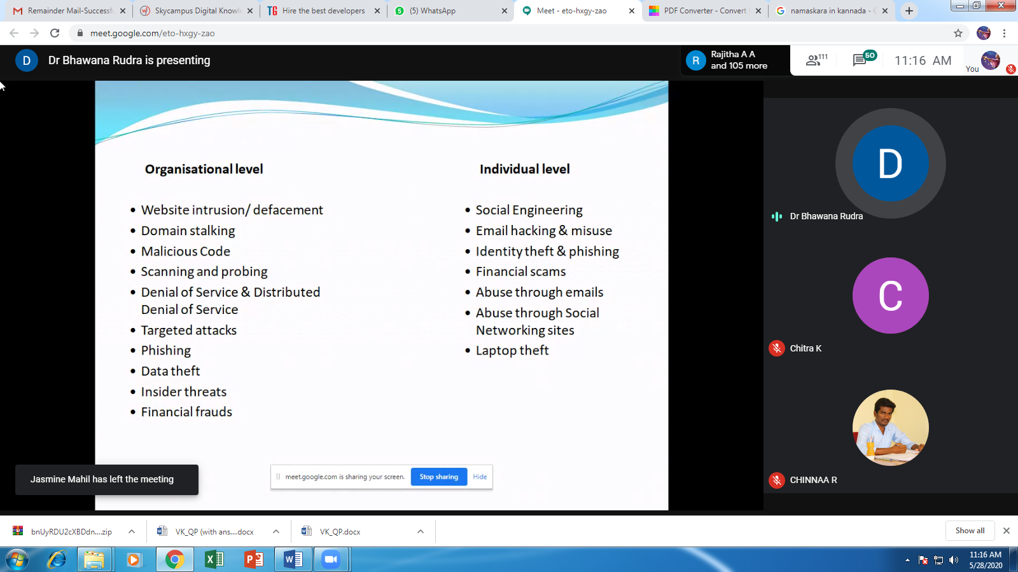
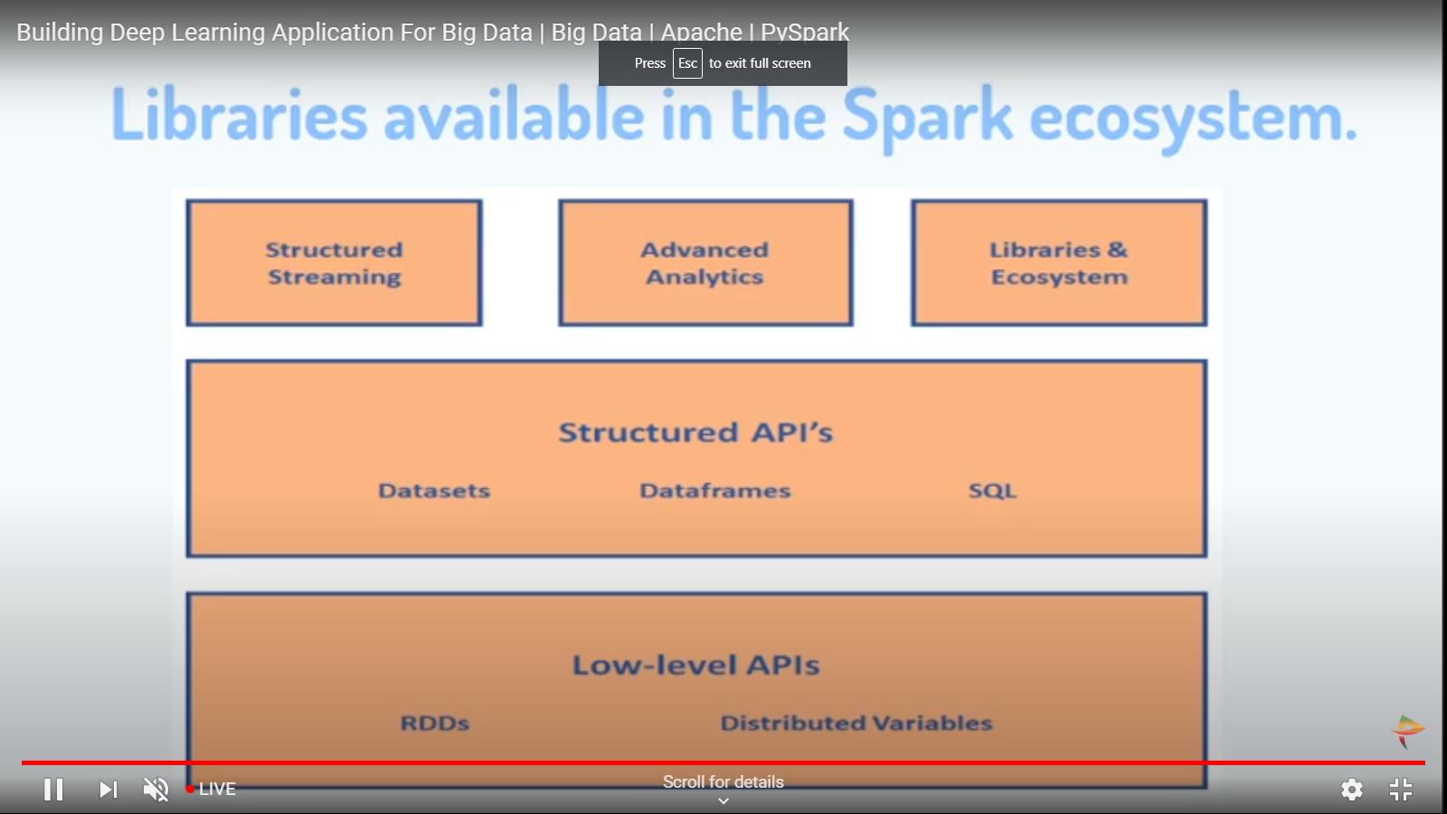

Students Report:


